English Vocabulary – 'very' vs 'much' (PT: 'muito')

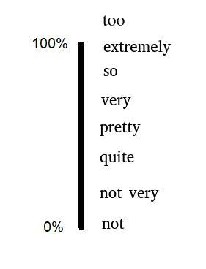
1) very (+ adjective)

The word 'very' is used to emphasize an adjective.
- He is very intelligent.
- I am very hungry.
- This test is very difficult.
- The wind is very strong today.
- I am very interested in your project.

The words 'not very' are used to diminish an adjective.
- He isn't very intelligent.
- I am not very hungry.
- This test isn't very difficult.
- The wind isn't very strong today.

2) very (+ adverb)

The word 'very' is also used to emphasize an adverb.
- He drives very quickly.
- I am very well today.

The words 'not very' are used to diminish an adverb.
- He doesn't drive very quickly.
- I am not very well today.

3) much (+ noun)

The word 'much' is used to show a large quantity.
- He has much money in the bank.
- I have much interest in your project.
- There is much coffee in the pot.

The words 'not much' are used to show a small quantity.
- He doesn't have much money in the bank.
- I don't have much interest in your project.
- There isn't much coffee in the pot.

4) much (+ verb)

The word 'much' is used to emphasize a verb.

- He eats much. He is very fat.
- I walk much. I am in good shape.

The words 'not much' are used to diminish a verb.

- He doesn't eat much. He is skinny.
- I don’t walk much. I prefer to drive.

5) much (+ comparative)

The word 'much' is used to emphasize a comparative.

- Your English is much better than it was. Congratulations!
- Tom is much taller than last year

The words 'not much' are used to diminish a comparative.

- Your English is not much better than it was. You should study more.
- Tom is not much taller than last year. You should take him to a doctor.

6) very much (PT: 'muito muito')

The words 'very much' are used for extra emphasis.
- He has very much money in the bank.
- I have very much interest in your project.
- There is very much coffee in the pot.
- He eats very much. He is obese.
- I walk very much. I love exercise.
- You helped me a lot. Thank you very much!

The words 'not very much' are used to minimize something.
- He doesn't have very much money in the bank.
- I don't have very much interest in your project.
- There isn't very much coffee in the pot.
- He doesn't eat very much. I am worried about him.
- I don’t walk very much. I should walk more.
- You didn’t help me at all. Thank you very much! (sarcastic)

Summary:
adjective – very She is very polite.
adverb – very He drives very slowly.
noun – much / very much He has (very) much money.
verb – much / very much She talks (very) much.

Exercise. Complete with 'very', 'much' or 'very much':
1) I have _______________ homework to do this week.
2) Maria is a _______________ beautiful woman.
3) Robert doesn't speak _______________ about his job.
4) I drink _______________ coffee. I think I am addicted.
5) This house is _______________ big! It has seven bedrooms!
6) My new car is _______________ faster than my old one.
7) He doesn't eat _______________ rice. He can’t be a Brazilian!
8) She always talks _______________! I never get a chance to speak.
9) He works _______________ during the week, so he relaxes all the weekend.
10) That bridge is _______________ high. I don’t want to cross it!
11) I love her, but she doesn’t love me ____________. I am ___________ sad.
12) It’s _______________ hotter in Fortaleza than in Curitiba.

